By

rofiat.ayagbe@womentechsters.org

28th May,2021

Practical Activity 2

rofiat Ajagbe

Rofiat.ayagbe@womentechsters.org

Practical 2

Step 1 deploy a windows server 2016 Gen 1 remotely from Azure cloud

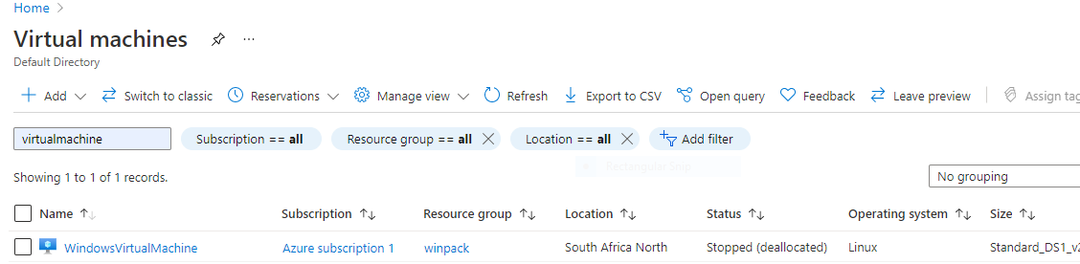

Step 2 Creating virtual window machine

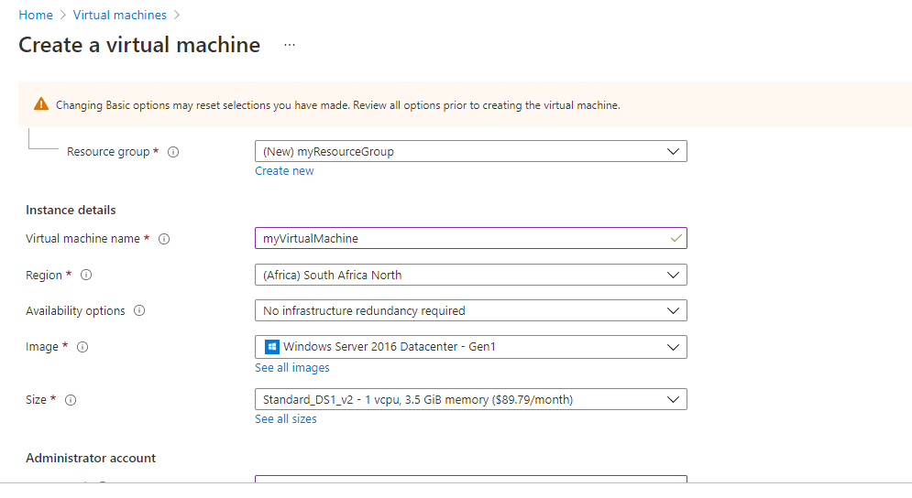

Step 3 Install the Azure server management tools and services

Created management group ID Cyberspace, display name cyberpractical

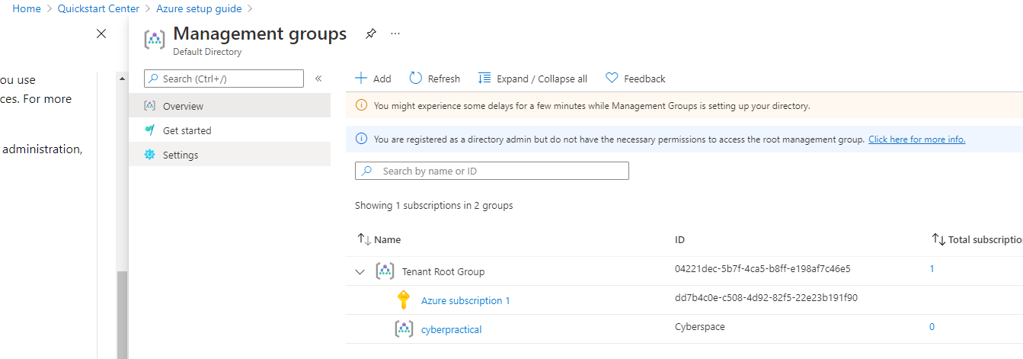

Step 4 Added Subscription to Management group created

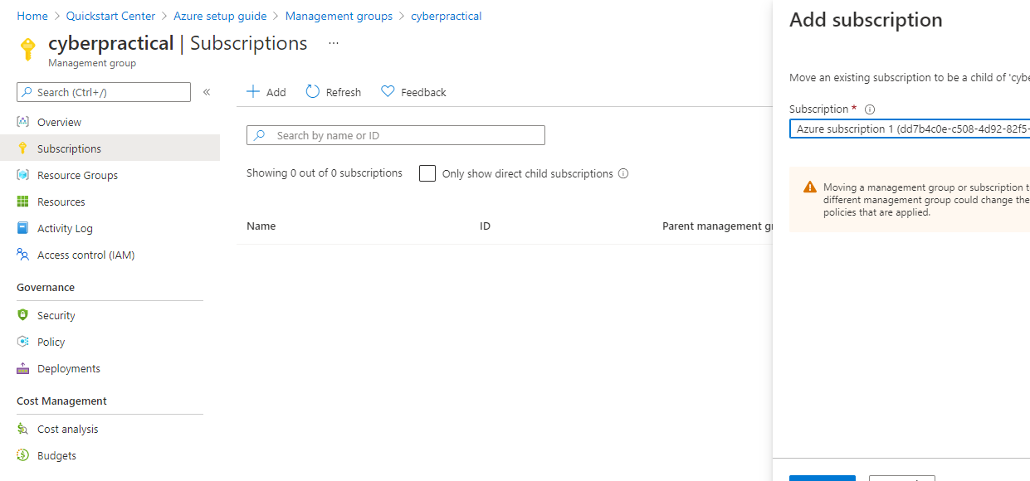

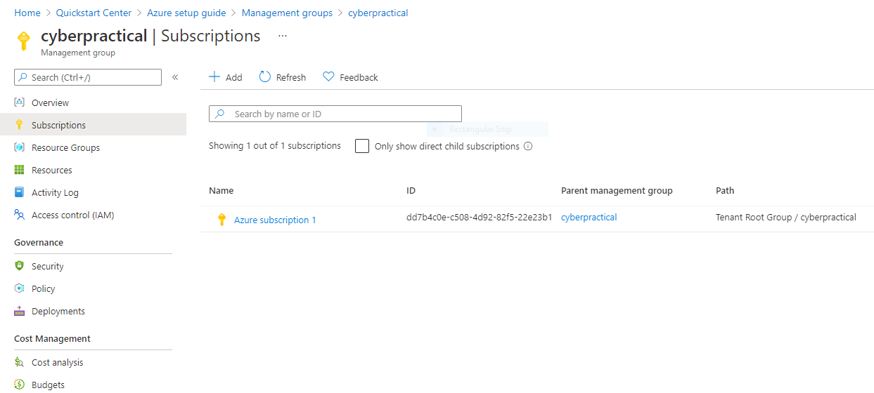

Step 5 Created new alert rule from the management group activity log

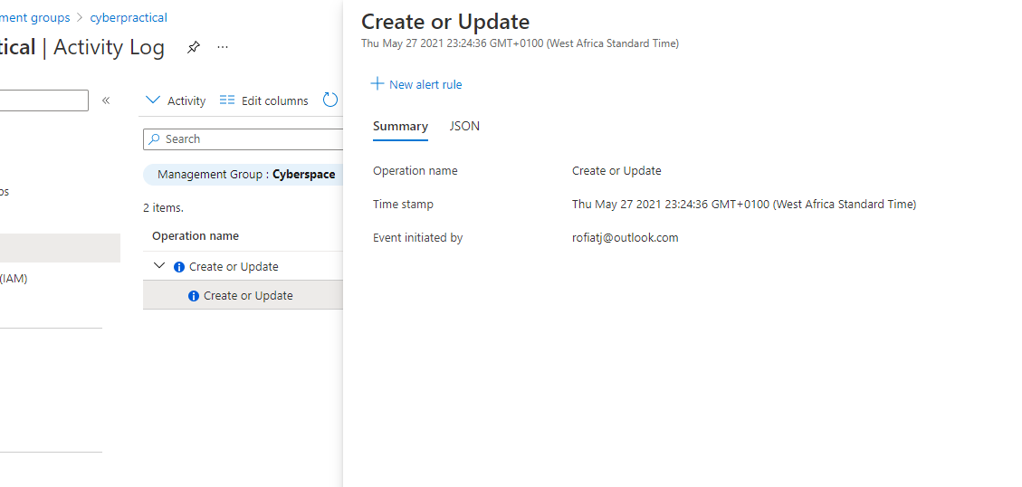

Step 6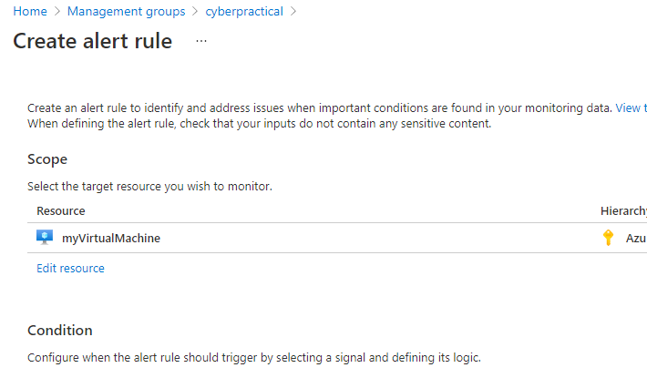

Step 6 confirming my windows vm is linked to the Management and resource group

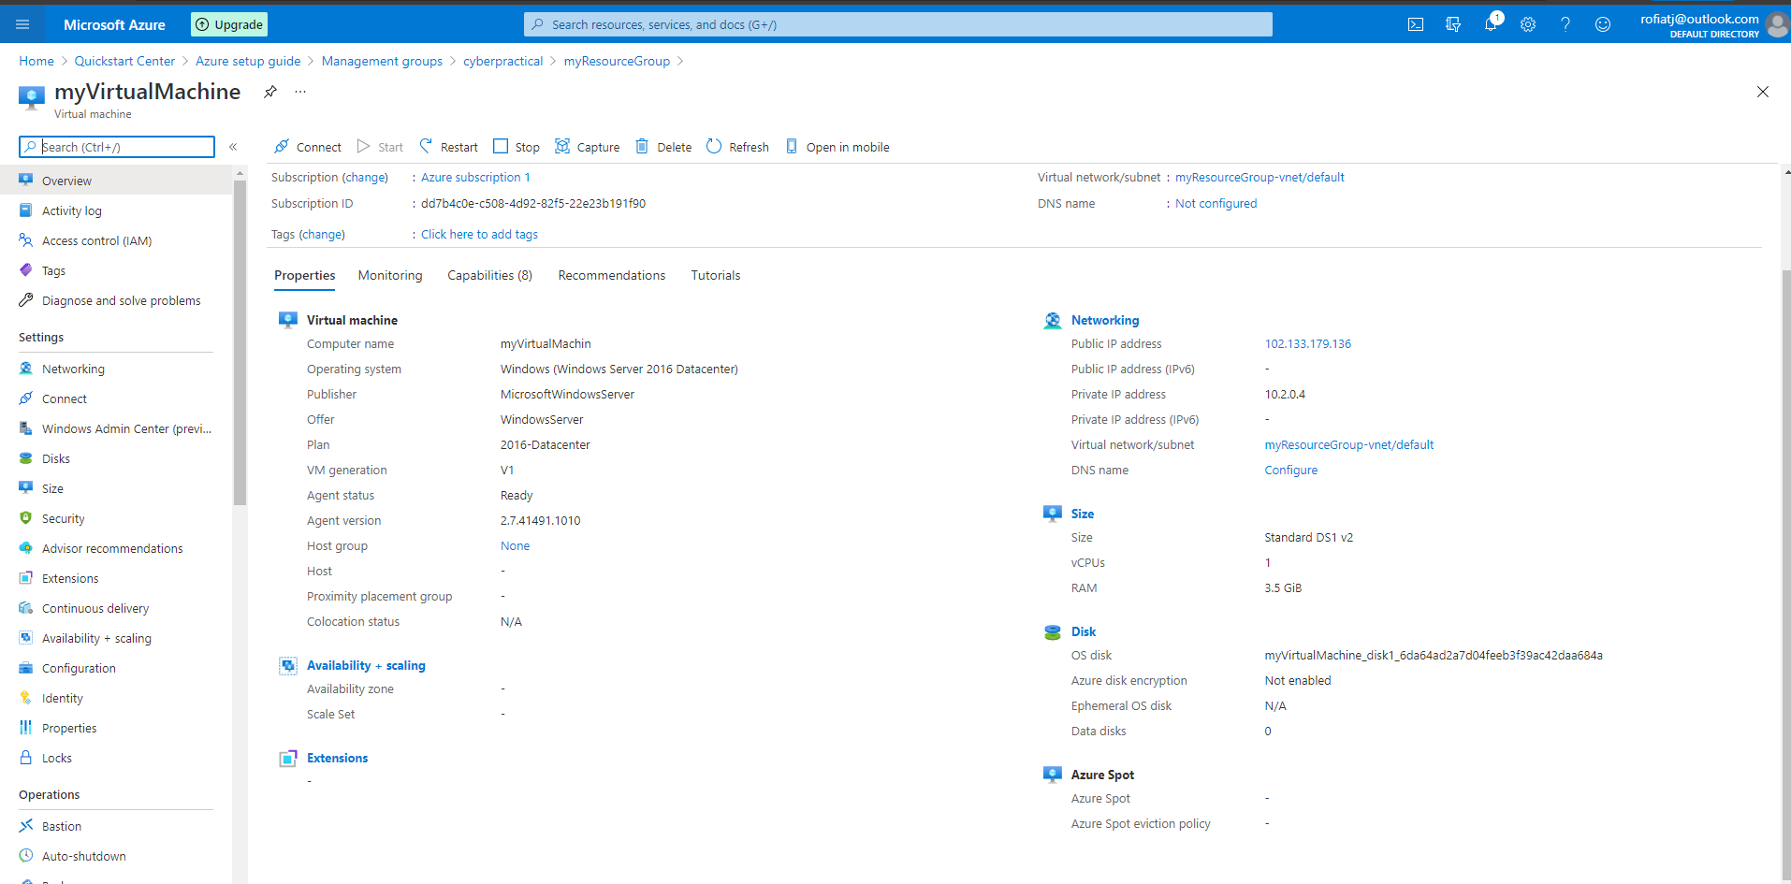

Step 7 Created recovery vault

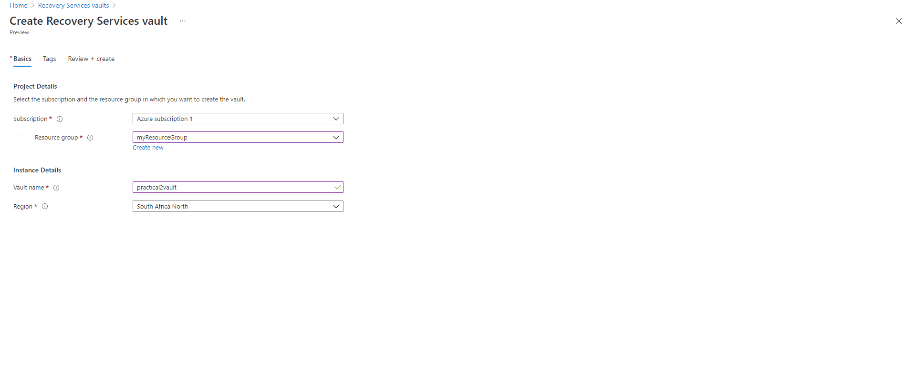

Step 8 Disaster recovery replication

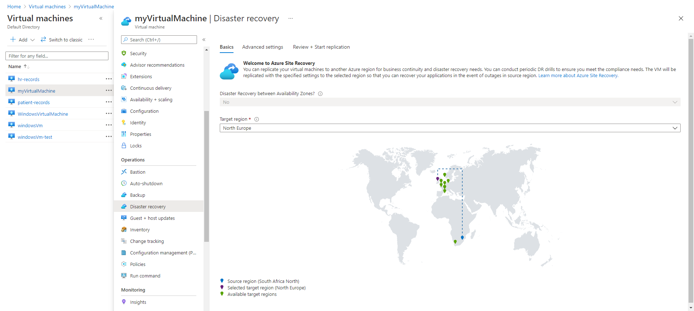

Step 9 Rhyming your region with North Europe for recovery

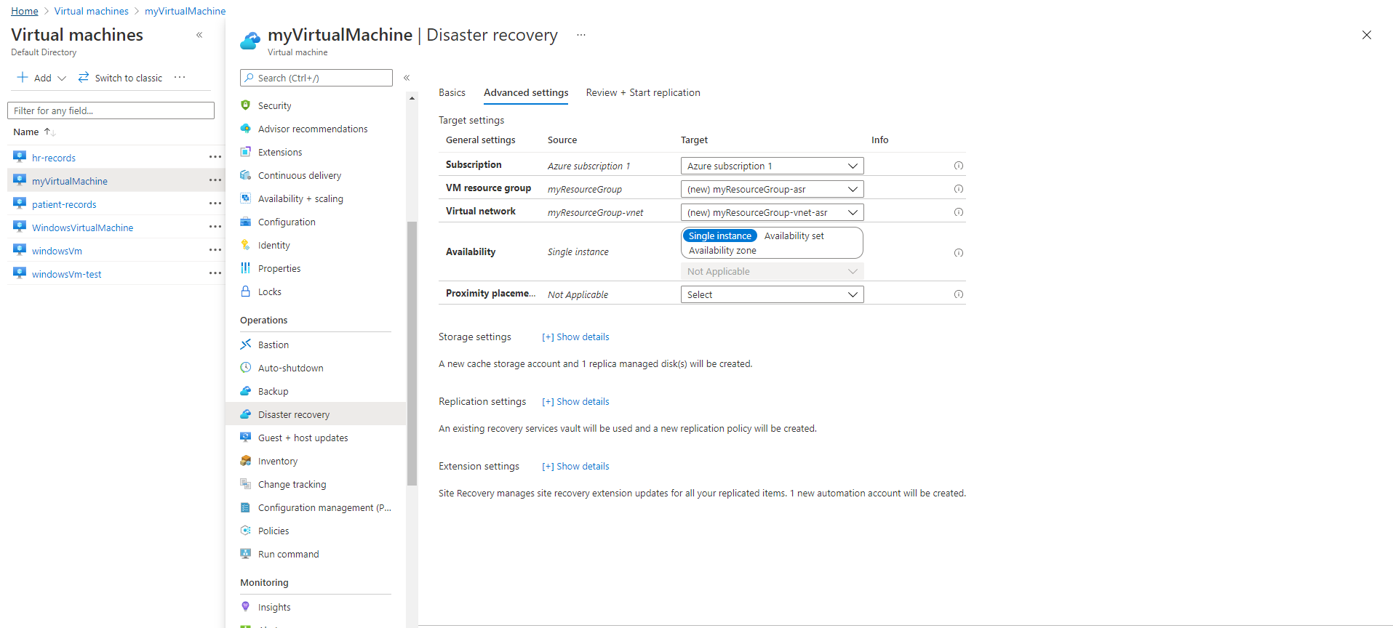

Step 10 Before replication of myVirtualMachine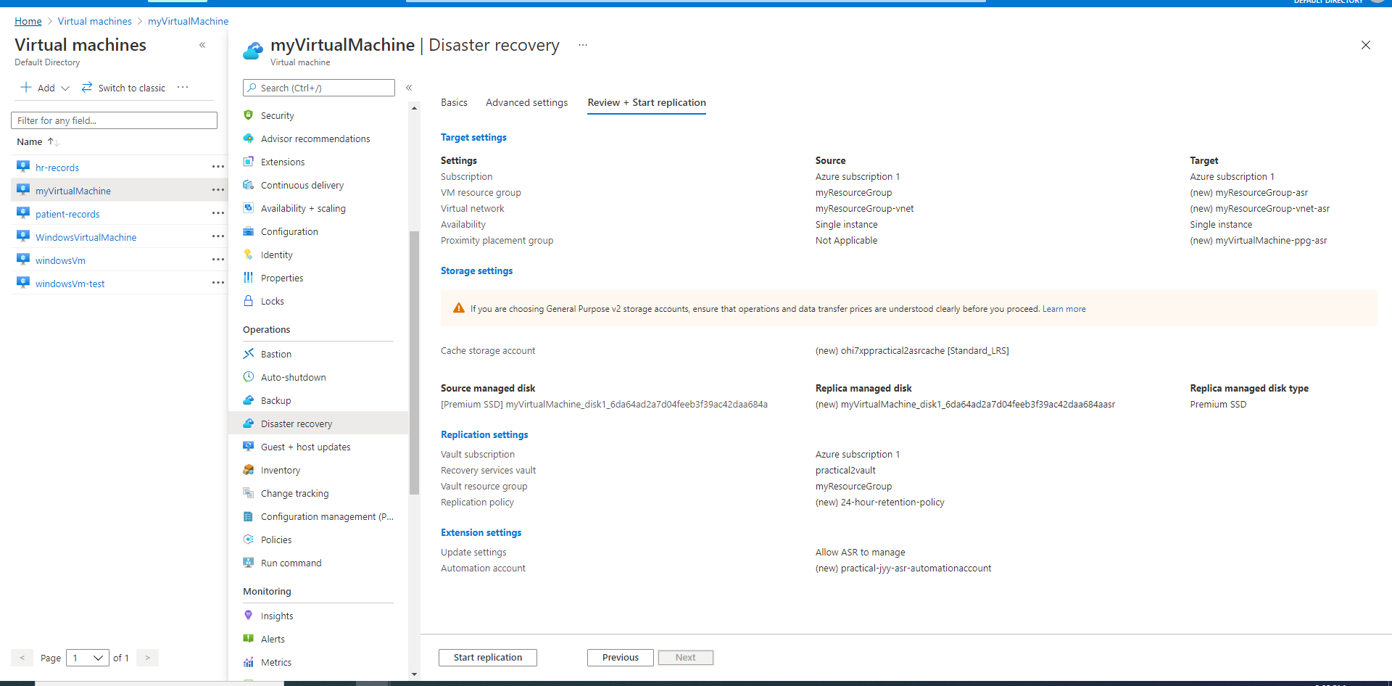

Step 11 Healthy myVirtualMachine Status

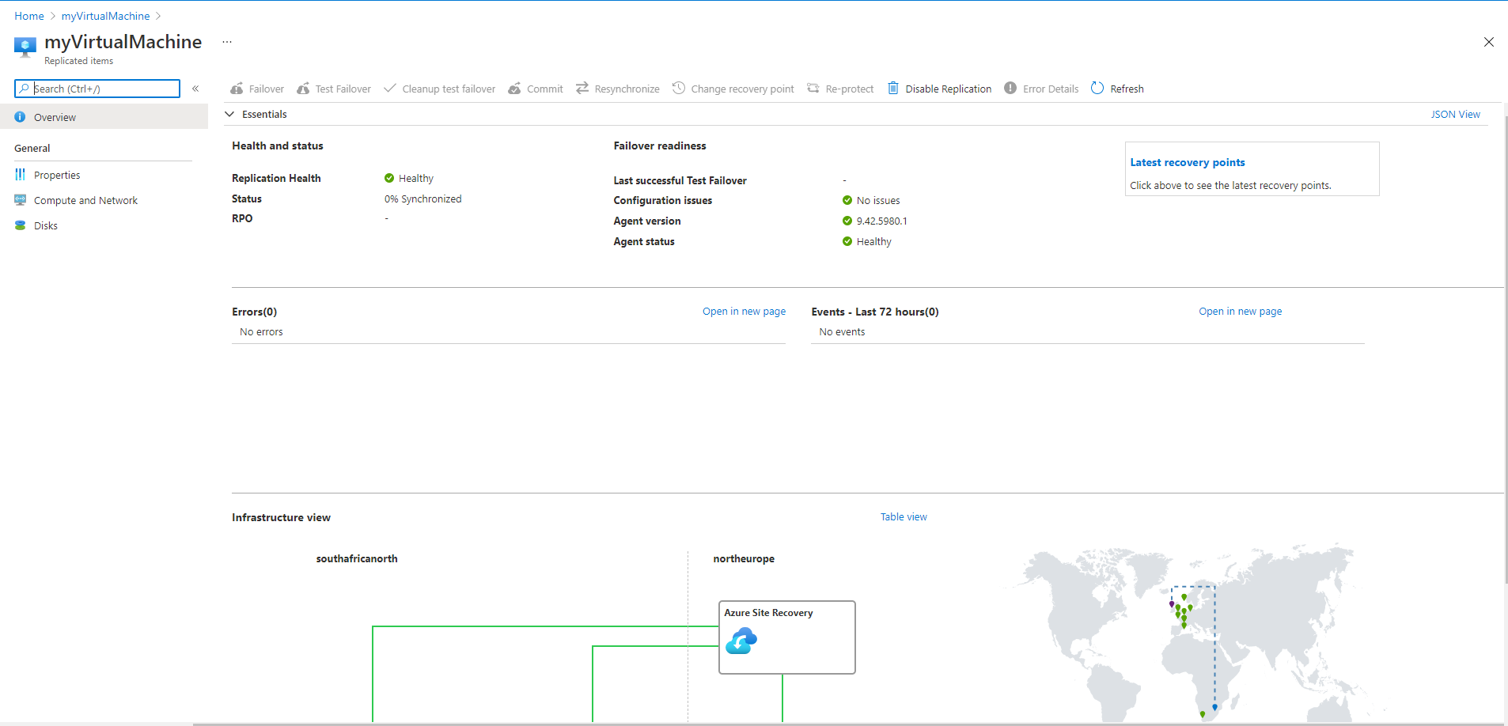

Step 12 myVirtualMachine now in protected mode.

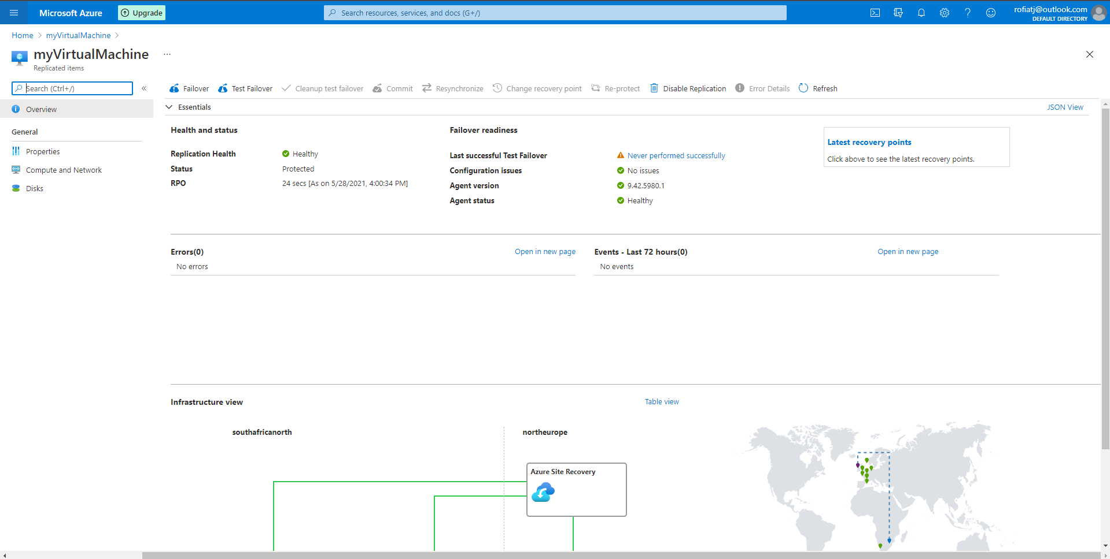

Step 13 Test failover for replicated myVirtual machine

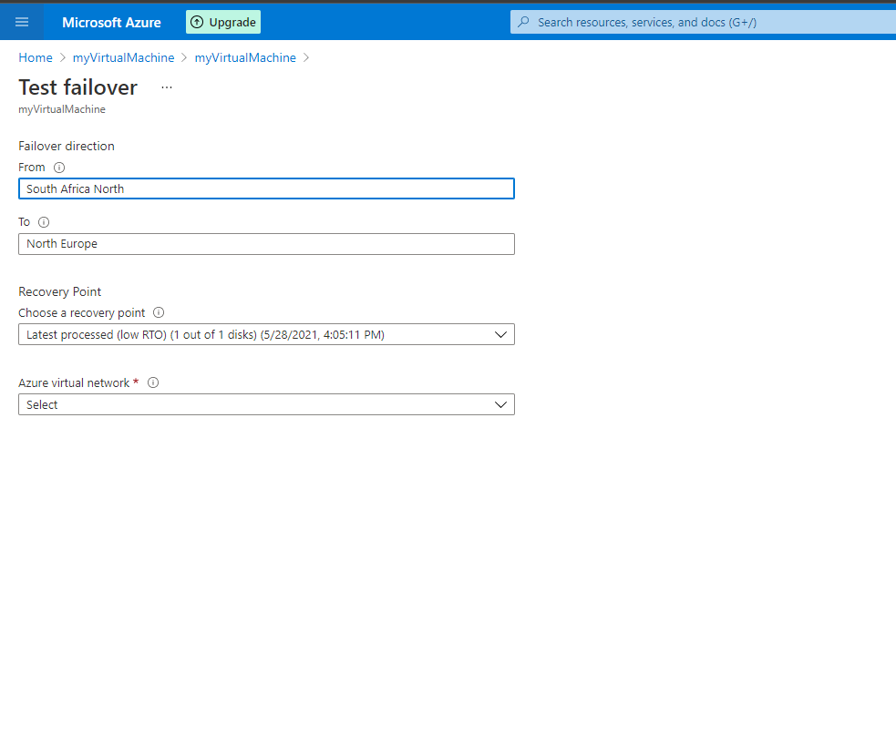

Step 14 Clean up test failover

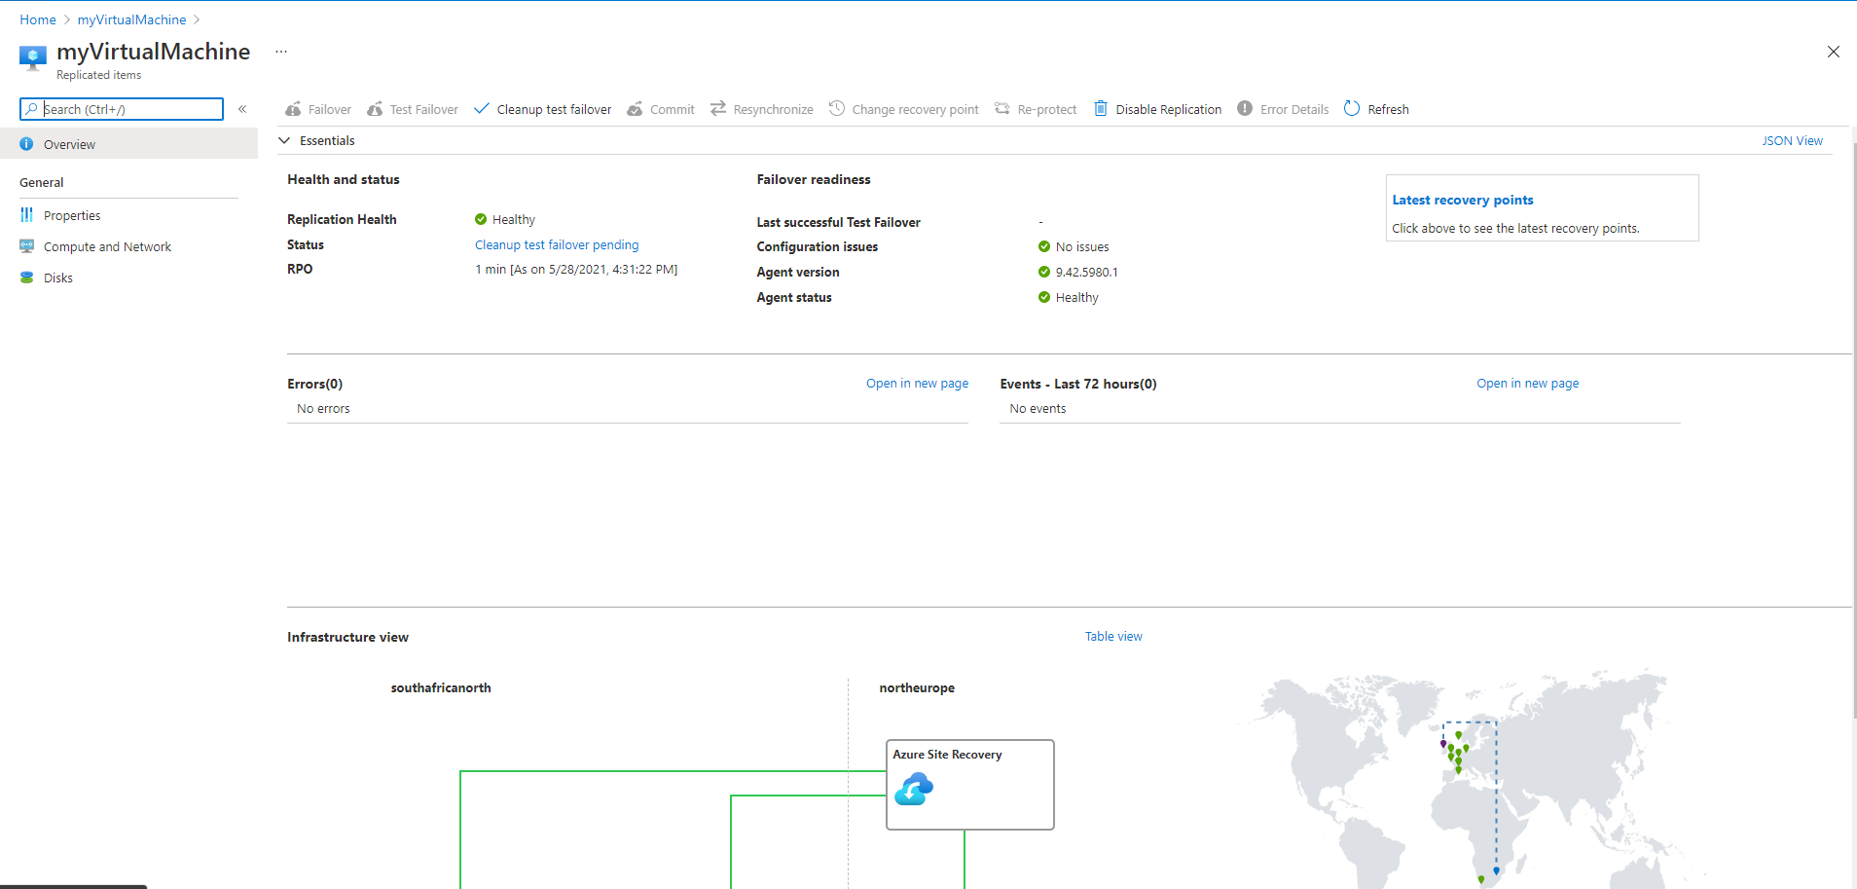

Step 15 New Ip config assignment

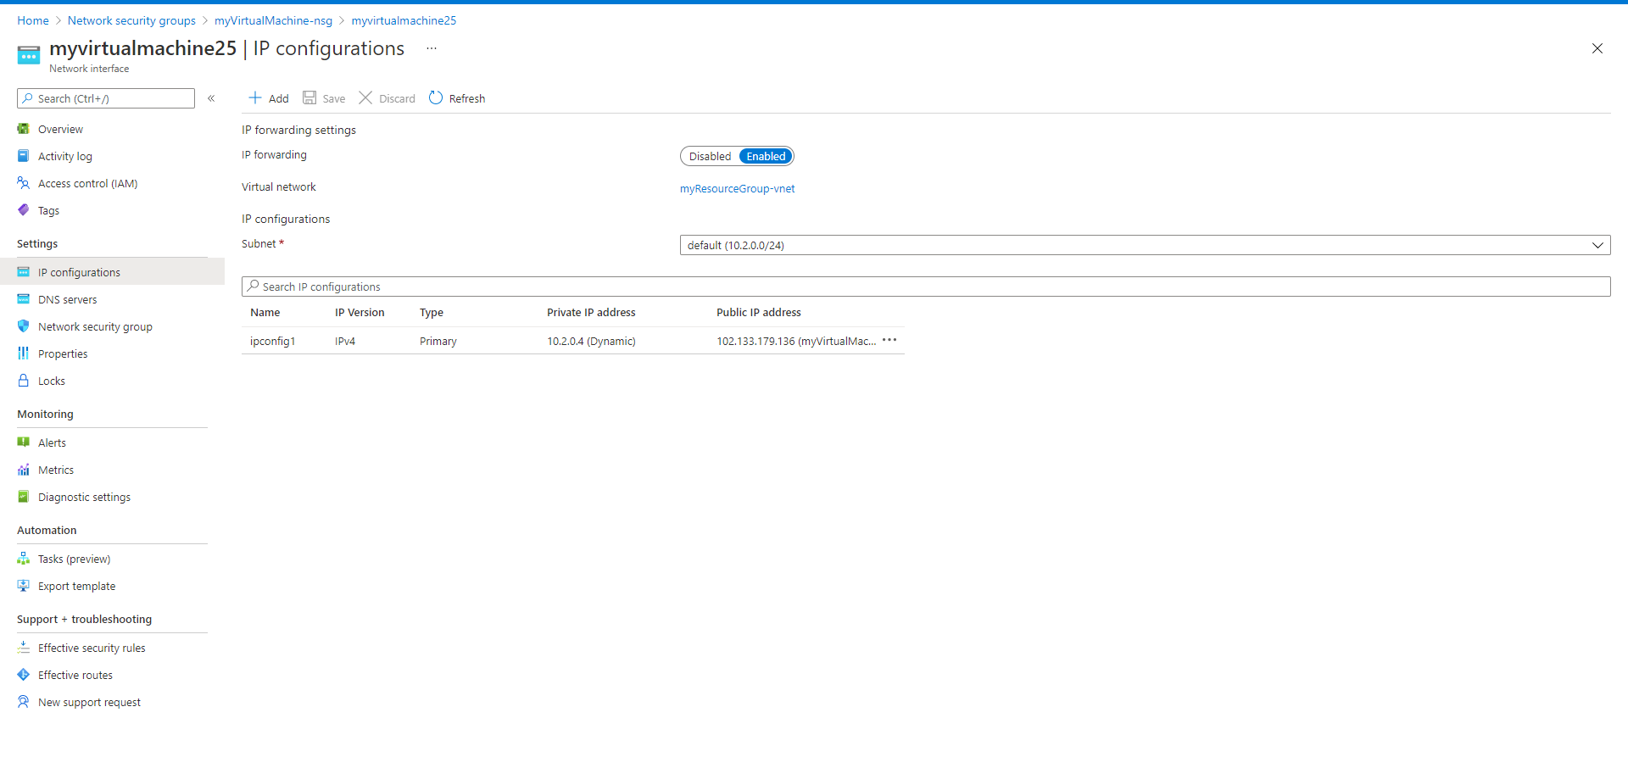

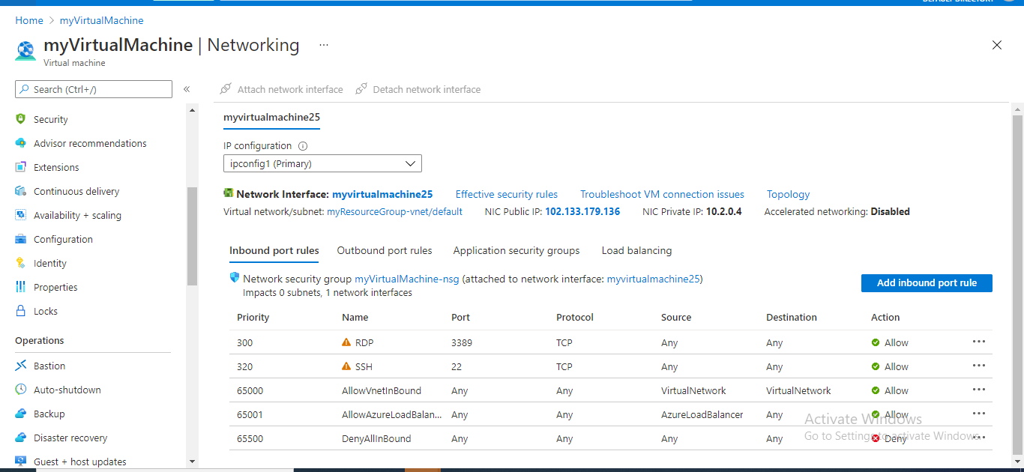

Step 16 Connecting to Virtual machine to desktop platform

